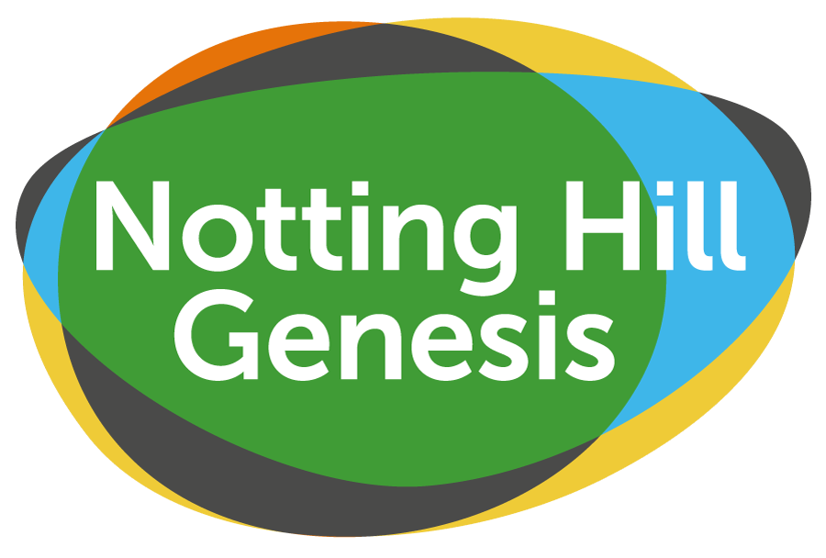

Notting Hill Genesis

Aylesbury Community Grants Application Form – Round 11 (up to £500)

Please write in capitals or type in black ink.
Use additional sheets if necessary.

Name of your organisation, group or resident’s name: | Date:

Contact details
Name of main contact person: ….…………………..

Address:………………………………………………………………………………………………

………………………………………………………………………………………………………….

Phone Number: ….……………… Email Address: ….……………………………….

About your project/activity
Project title:

Please describe the project/activity for which you are applying for a grant:

How do you know that there is a local need or interest for this project/activity?

How many people do you expect to benefit from your project or activity?

Who is the target group for the activity (i.e. young people, older people, etc)?

*Please note that projects must benefit residents from the Aylesbury and surrounding area.

Will your project/activity involve working with children/young people under 18 years old or vulnerable adults unsupervised? Yes No

*Please note you will need to have a Safeguarding and/or child protection policy in place if the project/activity involves working with unsupervised vulnerable people. Please speak with a member of the Aylesbury Community Grant Panel for more information.

Project Finances
How much will your project cost in total?
Please describe how the money will be used?

Agreement & Signatures

It is vital that this section is completed. Any forms without signatures and relevant documents will be returned to the applicant and will not be considered for funding.

If awarded a grant:

- I will ensure that the grant is used for the purpose outlined in this application
- I will ensure that the grant is spent within 12 months of receiving the grant payment
- I will provide receipts as proof of expenditure
- I will complete an evaluation form and provide photographs and other documentation at the end of the project

Name: ………………………………………………………………………………………………….

Signature: ……………………………………………………………………………………………..

Date: ….………………………………………………………………………………………………..

Consent

We may use photos you send from your project for publication. Please tick if you agree for your material to be used in any of Notting Hill Genesis’ publications.

Yes No

PLEASE RETURN YOUR SIGNED FORM BY EMAIL TO: aylesbury@nhg.org.uk

PLEASE KEEP A COPY OF YOUR APPLICATION
FOR YOUR REFERENCE

